**Project Design Phase-II**

**Data Flow Diagram & User Stories**

|  |  |
| --- | --- |
| Date | 22 March 2025 |
| Team ID | PNT2025TMID06680 |
| Project Name | Global Food Production Trends and Analysis A Comprehensive Study from 1961 to 2023 Using Power BI |
| Maximum Marks | 4 Marks |

**Data Flow Diagrams:**

A Data Flow Diagram (DFD) is a traditional visual representation of the information flows within a system. A neat and clear DFD can graphically depict the right amount of the system requirement. It shows how data enters and leaves the system, what changes the information, and where data is stored.

**Data Flow Diagram:**

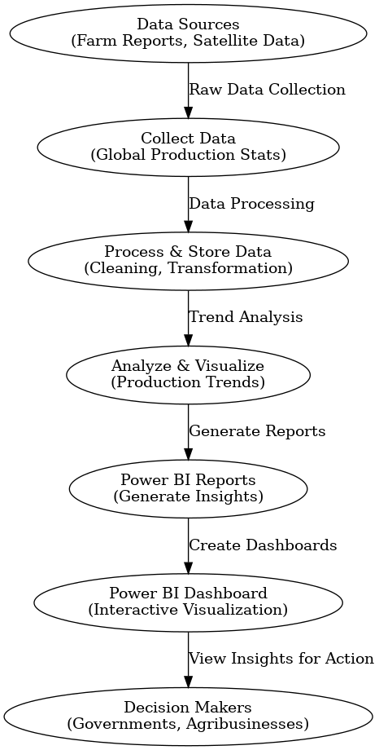

**User Stories**

Use the template below to list all the product's user stories.

